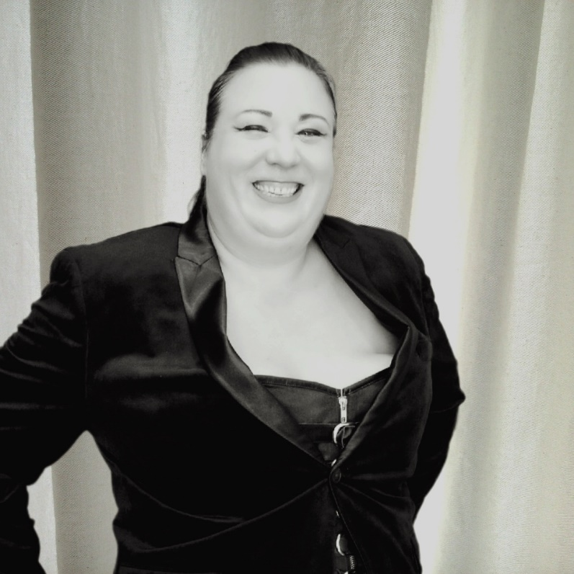
Rebecca E. Blanton
(aka Auntie Vice)
Contact Information:
RebeccaEBlanton@yahoo.com
Auntie.Vice@gmail.com
AuntieVice@FatChicksOnTop.com
+1.443.388.0244 (mobile)
Social Media and Websites:
AuntieVice.com (site)
LoveLettersToAUnicorn.com (blog)
FatChicksOnTop.com (podcast)
@AuntieVice on Twitter, Instagram, TikTok, Reddit, Facebook
@AuntieViceNSFW on Instagram

>500 Character Bio

Rebecca Blanton, aka Auntie Vice, is a writer and kink educator. She holds a Ph.D. in Political Psychology and a BA in Psychology. Their work focuses on gender, power, and kink//BDSM. She the runs the award-winning blog LoveLettersToAUnicorn.com and has published several books, including The Big Workbook for Submissives. Their forthcoming book, Brave & Crazy: Navigating BDSM with a Neuroatypical Brain will be published by Jennifer Kingsley Publishing in 2026.

Short Bio (115 words)

Rebecca Blanton, aka Auntie Vice, is a writer and kink educator. She holds a Ph.D. in Political Psychology and a BA in Psychology. Their work focuses on gender, power, and kink//BDSM. She the runs the award-winning blog LoveLettersToAUnicorn.com and has published several books, including The Big Workbook for Submissives, a finalist for the 2018 Golden Flogger Award. She has taught about kink and submission for the past decade. Their forthcoming book, Brave & Crazy: Navigating BDSM with a Neuroatypical Brain will be published by Jennifer Kingsley Publishing in 2026.

Prior to turning her attention to kink education and writing, she served as the Executive Director for the California Commission on the Status of Women and Girls and worked as a Senior Policy Analyst for the California Research Bureau.

Long Bio (415 words)

Rebecca Blanton, aka Auntie Vice, is a writer and kink educator. Their work focuses on gender, power, and kink//BDSM. She the runs the award-winning blog LoveLettersToAUnicorn.com and has published several books, including The Big Workbook for Submissives, a finalist for the 2018 Golden Flogger Award.

She has taught about kink and submission for the past decade. Their classes focus on the softer skills in kink and BDSM. She teaches extensively about power exchange and mental health, living with chronic disabilities and ways to adapt kink to meet physical and mental health needs. She also teaches about creativity, the senses and how to create the kinky scenes and relationships you desire. Her cornerstone course is “30 Days of Kinky Self-Discovery” which provides participants a deep dive into their identity, desires and needs.

She regularly performs stand-up and storytelling. She has appeared on Risk! The Show, Bawdy Storytelling, Submission (SF), and other shows which focus on sexuality and kink. Her performances explore how sexuality and the body mediate our interactions with others and the world.

She started the podcast Fat Chicks On Top in 2019 to talk to a wide range of folks left out of the body-positive movement. She has interviewed adult film stars, people with visible and invisible disabilities, “super fats”, non-binary and trans people, sex workers and more. She uses the platform to provide people with a voice who normally are not heard in the larger din.

She holds a Ph.D. in Political Psychology. Her dissertation Educating Americans: Multiculturalism and Civic Identity Development (unpublished) provided some of the only quantitative data showing the impact of high-level exposure to multicultural history studies verses low levels of exposure and long-term impact on civic identity. Prior to turning her attention to kink education and writing, she served as the Executive Director for the California Commission on the Status of Women and Girls and worked as a Senior Policy Analyst for the California Research Bureau (CRB). While at the CRB, her work on the needs of women veterans gained national attention and is the basis for more than two dozen state and federal laws.

She is agender, queer, bisexual, and disabled. Diagnosed with systematic scleroderma and systematic lupus in her 40s she has used her personal experience to advocate for greater visibility of dynamic disabilities and expose the sexism and bigotry embedded in the American medical system.

She lives with her partner, CharRon, and her mother in northern California along with two very active poodles.

